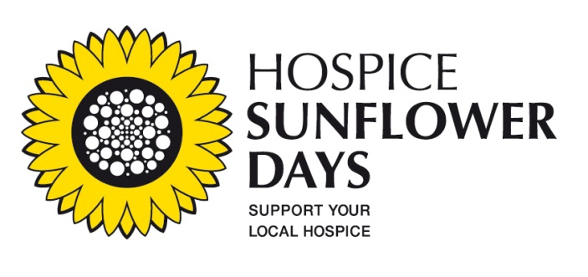
PRESS RELEASE
8th May 2013
For immediate release.

Support your local Hospice Service on Sunflower Days – June 14th and 15th -
The hospice movement in Ireland has appealed today (8th May) to the public to give generously on Hospice Sunflower Days next month and also to volunteer their time to take part in the two day collection.

The Irish Hospice Foundation (IHF) announced that the national Hospice Sunflower Days collection for local hospice services will take place on Friday, 14th June and Saturday, 15th June. People will be able to support their local hospice service by purchasing various pieces of Sunflower merchandise including sunflower pins or sunflower seeds for €2 each from collectors on the streets of cities, towns and villages around the country.
Hospice Sunflower Days is a major source of income for hospices and voluntary hospice groups countrywide. The IHF coordinates the event on behalf of the hospice movement but all of the funds raised locally, stay locally.

Launching Hospice Sunflower Days, Mary Kennedy remarked: “Hospice care in Ireland is a real grassroots movement as communities endeavour to ensure that local services are in place when their loved ones, friends and neighbours are at their most vulnerable. Hospice Sunflower Days is an opportunity for people to contribute to that endeavour. We hope that people will use Sunflower Days as an opportunity to volunteer for local collections or to make a much needed donation to their local service.”

Mo Flynn, Chief Executive Officer of Our Lady’s Hospice and Care Services and Chair of the Voluntary Hospices Group, commented: “Hospice services across Ireland continue to have their funding cut and we are therefore becoming more and more reliant on the generosity and goodwill of our supporters to continue to deliver our high levels of quality care to our patients and their families. At the same time, the numbers of people seeking hospice care is increasing. We are so grateful to the public for their support which has allowed hospice services to continue to bring comfort and dignity to people at the end of their lives.”

The launch of Hospice Sunflower Days was also marked with presentation of awards to “Sunflower Heroes.” In place for four years, this initiative honours the work of volunteers throughout the country, who work tirelessly on behalf of their local hospice service.

Hospice or palliative care involves the total care of patients and their families at the stage in a serious illness, where the focus has switched from treatment aimed at cure to ensuring quality of life. About 29,000 people die annually in Ireland and over 6,000 people use hospice services every year.

International studies have shown that patients using hospice services consume at least 25% fewer medical resources than those who access “usual care.” This saving is linked to the fact that many palliative care patients are cared for and die at home and they use much less acute hospital services. Hospice patients also live longer and in greater comfort and dignity.

For more information and to volunteer with your local hospice service for Hospice Sunflower Days visit www.sunflowerdays.ie

- Ends –

For more information, please contact:

Kirana Bhagwan, Communications Coordinator, The Irish Hospice Foundation

Tel: 087-6548915 or Kirana.bhagwan@hospicefoundation.ie .

Caroline Lynch, Head of Communications and Advocacy, The Irish Hospice Foundation

Tel: 087-123 75 86 or caroline.lynch@hospicefoundation.ie

