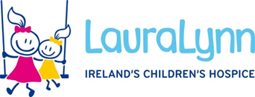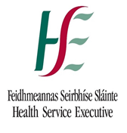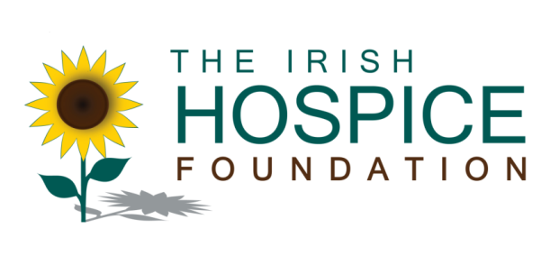

**PRESS RELEASE**

**Monday 4th March 2013**.

Immediate release.

**REPORT FINDS GROWING NEED FOR RESPITE CARE FOR CHILDREN WITH LIFE-LIMITING ILLNESSES**

Minister for Children and Youth Affairs, Frances Fitzgerald T.D. today (March 4th) launched a national report into respite services for children with life-limiting conditions which highlighted that service deficits exist and families face challenges in accessing respite care.

[*Respite Services for Children with Life-Limiting Conditions and their Families in Ireland. A National Needs Assessment*](http://hospicefoundation.ie/wp-content/uploads/2013/03/Respite-Services-Assessment-Final.pdf)found that while respite services are provided in all four Health Service Executive (HSE) regions, access was often dependent on the geographical location of the child and their diagnosis. The report estimated that up to €7.6m was currently needed to provide respite care for about 812 children and €8.62m would be required to care for 925 children by 2021. This works out as an average of less than €10,000 per child being invested in respite services.

An estimated 1,400 children are living with life-limiting conditions in Ireland and about 350 children die from a life-limiting condition each year - the majority in the first year of life.

Jointly funded by LauraLynn, Ireland’s Children’s Hospice and the Irish Hospice Foundation (IHF), in partnership with the Health Service Executive, the report recommended that to ensure that children have appropriate and timely respite care, a number of key actions should be taken including:

* The National Development Committee for Children’s Palliative Care should oversee the development of national standards for the provision of respite care, promote understanding of terminology and examine the feasibility of developing an assessment tool for respite services
* Each HSE region should set up a regional group to map existing local respite services, identify family needs and plan for future provision
* Health services should work with regional respite service providers when out-of-the-home respite is needed
* The education and ongoing support needs of organisations providing respite should be considered
* A national needs assessment should be repeated in 2017.

More…

2.

Minister Fitzgerald stated: “Under our 2010 national policy on palliative care for children with life-limiting conditions, respite care is recognised as an essential element of a comprehensive palliative care service*.* I welcome the collaboration between the voluntary sector and the HSE in producing this report which sets out very clear steps that need to be taken in developing a responsive, child friendly and flexible respite service for children with life-limiting conditions. The government will be interested in seeing progress being made in implementing the recommendations in this report.”

Commenting on the report, Dr Mary Devins, Consultant Paediatrician with a special interest in palliative care, said: “Caring for a child with a life-limiting condition at home is both rewarding and challenging. It can be emotionally and physically demanding for the family. Respite is recognised as an essential element of a palliative care service as it offers ‘time out’ for caregivers who can get some rest, tend to their other children or get basic chores done. We must ensure that respite services within and outside the family home are flexible and responsive to the child and family needs.”

UK research would suggest that a well-structured respite service can reduce hospital admissions because it provides the additional community supports that may prevent a child’s condition from deteriorating to a point where hospitalisation becomes necessary and because many therapeutic procedures may be completed as part of a respite programme.

Dr Ciaran Browne, National Lead for Acute Hospital Services and Palliative Care, HSE, commented:“Despite the current economic challenges within health care provision significant progress is being made on the implementation of the 2010 national policy on children’s palliative care. This has been largely achieved through the strong commitment of the statutory and voluntary sectors in adopting a partnership approach as reflected within the National Development Committee for Children’s Palliative Care. This committee will oversee the implementation of the recommendations of this report to ensure that children and their families have easier access to existing and developing respite care services.”

Philomena Dunne, CEO of LauraLynn, Ireland’s Children’s Hospice, commented: “This report is a hugely welcome blueprint for how we can improve service provision for the children and families in our care. The report concludes with the hope that the 2017 needs assessment will identify tangible improvements in the provision of respite services for children with life-limiting conditions. 2017 is four years away, but we simply cannot wait until that deadline is upon us because the fact is these children simply don’t have the time to wait four years for these proposals to be implemented. We at LauraLynn are looking forward to working with everyone here today to make sure these excellent proposals are translated into reality as soon as possible”.

Sharon Foley, CEO of the IHF, remarked: “A key recommendation of this report is that regional groups comprising all local providers be set up and take the lead in developing the right services for the children with respite needs in their community. Many resources already exist in the regions to meet needs but regional planning is required to develop these services strategically so as to meet the needs of all children requiring respite”.

This needs assessment *was* completed to assist in the implementation of the policy document *Palliative Care for Children with Life-limiting Conditions in Ireland - A National Policy* which was launched by the Department of Health & Children in March 2010. This policy recognises that respite is an essential element of a comprehensive palliative care service for children.

Ends

**For more information, please contact:**

Caroline Lynch Jane Flynn

Head of Communications and Advocacy, Marketing & PR Manager

The Irish Hospice Foundation LauraLynn Ireland’s Children’s Hospice

Tel: 087-123 75 86. Tel: 01-2893151 / 087-235 6801

**Note to Editor**

LauraLynn, Ireland’s Children’s Hospice offers support and care for children with life-limiting conditions and their families by providing high quality transitional care, home support, respite, crisis and end-of-life care.

The IHF is a national charity which promotes the hospice philosophy and the development of hospice care in Ireland. The IHF has committed €2.5 million to the implementation of the 2010 national children’s policy *–* a sum which is85% of the funding required for this first phase of this programme.

Click [here](http://hospicefoundation.ie/wp-content/uploads/2013/03/Respite-Services-Assessment-Final.pdf) to read full report